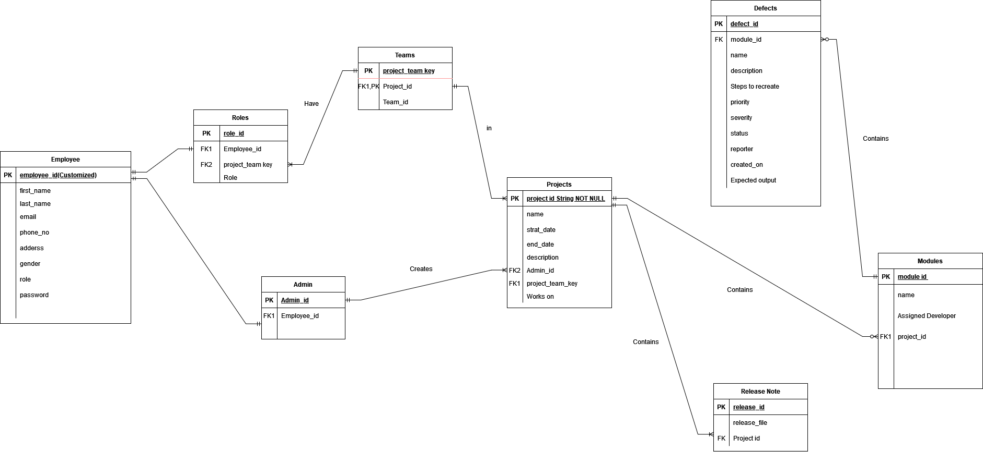**Entity Relationship Diagram for Defect Tracking System – Team B**